Kingfisher School of Business and Finance
1799 MacArthur Highway, Lucao District, Dagupan City



A Pre-Feasibility Study

Arrieta, Joe Nathaniel R.
Calderon, Krystia Carmela A.
Collado, Chryselle Ellis S.
Cruz, Von Zedrick B.
Dimaunahan, Janny C.
Eslera, Bernard Joseph C.
Nepacena, Emman Bryll U.
Sagun, Jessabel S.

TABLE OF CONTENTS
Executive Summary 2
I. Introduction 4
A. Company Background 4
B. Vision Statement 7
C. Mission Statement 7
D. Objectives 7
E. History 8
F. Product Description 9
G. Location Profile 14
H. SWOT Analysis 16
H.1. Strengths 16
H.2. Weaknesses 17
H.3. Opportunities 17
H.4. Threats 19
II. Industry Overview 21
A. Industry Analysis 21
B. Supply 26
C. Demand 26
D. Porter’s Five Forces Model 28
D.1. Bargaining Power of Suppliers 28
D.2. Bargaining Power of Customers 29
D.3. Threats of New Entrants 30
D.4. Threats of Substitutes 31
D.5. Competitive Rivalry Between Existing Players 32
E. Competitors’ Profile 35
F. Supplier’s Information 40
III. Review of Related Literature 42
References 48
Appendix 51
Appendix A: Interviews and Surveys 51
Appendix B: Initlal Estimates of Various Budgets 53

Executive Summary
Flavo’Lechon is engaged in producing and selling the classic flavored roasted chicken along with other variants, such as spicy, cheese-stuffed, barbeque, and curry, which will be offered to the residents and travellers in Malasiqui, especially those who do not have much time to cook their own food . Aside from the roasted chicken, the business will also serve liempo as an alternative to the main product. For the convenience of customers, the business also serves delivery services to accommodate orders, especially for bulk orders.
The business will be located in Quezon Blvd., Malasiqui, Pangasinan for its concentrated population near the town hall and proximity to the public market and malls where abundance of the suppliers of the ingredients, charcoal and other supplies can be found. Moreover, it gives a chance for the business to serve travelers and daily commuters because it is near the bus and jeepney stops.
The investment required in establishing the business amounts to Php 734,000 which includes annual rent, rotisserie and signage, cooking materials, refridgerator, delivery vehicle, business permits, supplies, and other funds. This will eventually generate a return on investment of approximately 10% every year.
Its vision is to be recognized as one of the well-known and leading brands in the chicken roasting business, while its mission aims to provide a whole new customer experience through innovation and continuous improvement. The business will not just sell but also serves convenience and satisfaction.
For the SWOT analysis of the business, starting with the strengths, it focuses on internal capabilities like having variants of roasted chicken, offering delivery services and having a business background from one of the proponents’ relatives. On the other hand, the weakness of the business includes having materials and products that are perishable, which could lead to immediate loss from excess supply. There are also opportunities for the business such as the vast population in the location which could enable the business to establish a bigger customer base. In addition, the business location is near the principal market where most people gather. Brand franchising and restaurants partnership were also considered as opportunities with regards to business expansion. On the contrary, the threats include the rough competition in the market, ease of imitation, the susceptibility of chicken to disease and the buying behavior of customers. These threats can be mitigated by introducing flavors of roasted chicken and establishing a strong supplier and customer relationship.
Results of surveys in the rotisserie stands in Malasiqui indicates that there is a material gap between the supply which is 16, 800 per month and demand which is 18, 930. In other words, there is a gap of approximately 2,130 roasted chickens per month which is favorable to open another chicken roasting business. These figures were derived from the daily production of the rotisserie stands and number of roasted chicken sold multiplied by 30 days.
The analysis of Porter’s five forces model results to these interpretations. The bargaining power of suppliers and the bargaining power of customers are moderate. Threat to new entrants is moderate. On the other hand, the threat of substitution is high. Based on the previous factors, therefore, the competitive rivalry between existing players is high because of the intense competition in the market caused by the existence of numerous competitors who contest for market share.
Flavo’Lechon’s supplier will be Magnolia for the supply of chicken, Charito’s Trading for charcoal and the principal market for the ingredients. These are chosen based on certain criteria which includes, but not limited to, quality and cost.
Chicken roasting business has proven its stability and longevity in the food industry. Therefore, entering in this business venture is a promising opportunity that may eventually lead to success. Flavo’Lechon use this opportunity to innovate and introduce the variants of roasted chicken which could potentially appeal to customers.

Introduction
Brought by the Spaniards, the roasted chicken has since then become one of the most favorite Filipino meals of all time. Roasted Chicken is not only a very tasty meal, but it can also be a great business. With the rise of several competitors across the country, innovations are made to create an advantage to the others. Flavo’Lechon is an innovation of roasted chicken which offers more options to customers, aside from the classic one, which best suit their tastes. The importance of this study is to give the readers, especially aspiring businessmen, an idea in putting up their own business using the information obtained and organized by the proponents. Moreover, it will also serve as grounds for opportunity for businesses to innovate their existing products which will improve their company and the society it belongs.

Company Background
Flavo’Lechon is a chicken rotisserie stand which serves the classic roasted chicken with other variants to choose from, such as spicy, cheese-stuffed, barbeque, and curry. These flavors are based from customer preferences, susceptibility to the market, and compatibility to roasted chicken. The business will also serve roasted liempo as an alternative to the chicken products, and offer delivery services for the convenience of the customer and discounts to bulk orders.
Being the first to introduce new variants of lechon manok in Malasiqui, FlavoLechon has the first mover advantage. However, in order to maximize this, the company must execute extensive promotional activities for its products. One of these promotional activities involves providing free tastes in malls near the area, as well as in the town proper to give the general public an idea or oversight about the variants of the lechon manok served by the business.
Next, FlavoLechon can also expand its promotional activities through the use of social media. Since almost all people have social media accounts, they can easily have access on the company's advertisements in the social media page. The business can also use tarpaulins and posters to introduce the products to the bypassers in the town proper, and even give flyers to spread the idea about the company's products. Extensive use of social media and advertising blogs to create brand awareness will form a wider market reach, and can stimulate the interest of the buyers out of curiosity.
Finally, the business can also use the word-of-mouth marketing which can be an effective form of promotion, Since satisfied customers may recommend the product to their friends and families. In addition, cost on advertising can be reduced.
The business will be located in Quezon Blvd., Malasiqui, Pangasinan. Malasiqui is a first-class municipality in the province of Pangasinan, Philippines with a population of 130,275 people as the of the 2015 census (Philippine Statistics Authority, 2016). The proponents have chosen Quezon Blvd., Malasiqui because of its concentrated population near the town hall, and it is near bus and jeepney stops, which can be a good business for daily commuters. The location is also near the public market and malls in which some of the supply of raw materials (i.e spices and flavorings) will be coming from.
The business will be organized as a closed corporation among the proponents. Registering a close corporation is relatively simple and affordable. It does not have substantial legal complications and has only few regulations that makes running a closed corporation easier. The amount of capital needed is normally more than the average sole trader or small business. As compared to a partnership, owners of a corporation have a limited liability, where their exposure to loss is limited to the amount invested in the corporation.
According to Jeronimo M. Nepacena, owner of Jerrylis, putting up a rotisserie business will require an initial investment of approximately Php 500,000-800,000. Moreover, it can result to a return on investment of around 10%, depending on the proper management and marketing of the business owners.
The proponents of Flavo’Lechon estimates that the business will need a total investment of Php 734,000, breakdown are as follows:
- Rent | 204,000
- Rotisserie and Signage | 150,000
- Other Cooking Materials | 30,000
- Delivery Vehicle | 55,000
- Permits and Processing | 10,000
- Working Capital Fund (1 month) | 300,000
- Office Supplies | 30,000
- Petty Cash Fund | 10,000
Total | 734,000

The rent is based on 12 monthly payments of Php 17,000. The cost of the rotisserie and signage and the permits and processing (B and E) was based from interviews and surveys from lechon manok owners. The estimations for cooking materials, office supplies, and working capital fund were based from fair value of the matierials needed. The delivery vehicle is based on the price of a Honda TMX 125 Motorcycle which is Php 49,900 and an allowance of Php 5,100 for the manufacturing of the box to be installed at the back of the vehicle. The petty cash fund is established by the proponents for small and unexpected disbursements.

Figure 1.1 The Company Logo and Name

The name “Flavo’Lechon” comes from the main product of the business which is the flavored Lechon. The business decided to create its own fun way to advertise with a mascot of a roasted chicken.

Vision Statement
To recognized as one of the most well-known and leading brands in the chicken roasting industry.

Mission Statement
Flavo’Lechon aims to provide a whole new customer experience through innovation and continuous improvement. The business does not just sell; it serves convenience and satisfaction.

Objectives
General Objective: To establish a brand and to gain market share in the food industry within Pangasinan.
Specific Objective: To generate increasing sales annually by at least 10%, set up payback period as low as five years, and establish a return on investment of at least 10% every year by building strong customer relationships through giving value to customers’ needs with proper management of the business, and via extensive marketing such as transactional and direct marketing.

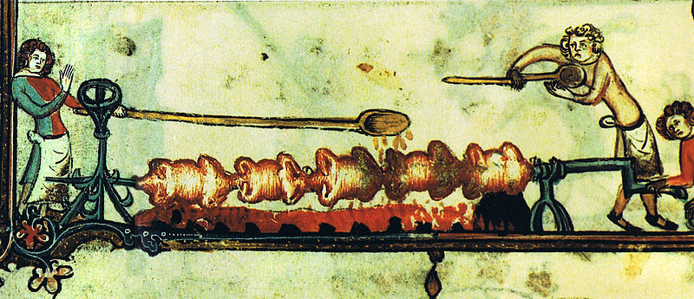
History

Figure 1.2 Chickens being roasted on a spit. Romance of Alexander,
Bruges, 1338-44

In medieval cuisine and early modern kitchens, the spit was the preferred way of cooking meat in a large household. A spit is a slender rod for holding meat over a fire. A worker, called "spit boy" or "spit jack", was responsible for turning the metal rod slowly and cooking the food. Rotisserie refers to a mechanical device used for rotisserie cooking, or to a restaurant specializing in spit-roasted meat. Rotisserie comes from the French word “rôtissoire“ where it first appeared in Paris shops around 1450 (Rotisserie Chicken, 2012).
Rotisserie chicken is a chicken dish that is cooked on a rotisserie with the use of indirect heat in which the chicken is placed next to the heat source (Krasner, 2007). In 1930s, ready-to-eat rotisserie chickens were always a popular item in United States as they were made available in super markets and some butcher shops. This quick meal option became well-established staple for decades as it gained additional popularity with Boston Market in 1990s. The rise in popularity of fast foods started after World War II wherein there was an increase in dinners eaten out which leads to fewer trips to the grocery store. In 2010, about 600 million rotisserie cooked chickens were purchased by customers in U.S. supermarkets, club stores and similar retail outlets (Benwick, 2012).
The rotisserie chicken craze started in the Philippines in the 1980s. It serves as an alternative to the “lechon baboy”, because it is easier to prepare and at the same time it is much cheaper. The top three pioneers of the lechon manok in the Philippines are Andok’s Manok, Baliwag, and Chooks-to-Go (Isla, 2015).

Product Description
Roasted Chicken, or commonly known to Filipinos as lechon manok, is one of the most favorite dishes of every family in the country. It is famous for its delicious and juicy taste, as well as its affordability and availability for every meals and special occasions.
It is made from dressed marinated broiler chicken, which is then rolled over live charcoal until the skin becomes golden brown colored. Being cooked over charcoal provides the chicken a distinctive smoked flavor and aroma.
Over the years, businesses offering such kind of food have been successfully improving their product lines, including their recipes, such as Chooks to Go with its theme of delicious chicken even without the sauce. As for Flavo’Lechon it will bring the simple and classic lechon manok to the next level by making innovations not presently offered by any business (i.e., to create variants of the same product in order to provide better customer value than the competitors). These variants include spicy, cheese-stuffed, barbeque, and curry which customers can enjoy. These flavors are chosen taking into consideration customer preferences, susceptibility to the market, and compatibility to roasted chicken. With the additional flavors and seasonings, the chicken will bring out a unique taste and good aroma. Aside from customers taking out orders from the rotisserie stand, Flavo’Lechon will also provide delivery options for bulk orders in special occasions.
Different Preparations of Roasted Chicken
- Classic
This is the most common and traditional way of preparation of lechon manok. The basic flavorings are a mix of garlic, onion, brown sugar, salt, ground pepper, and lemongrass or tanglad. This is served with a gravy that is based on chicken stock, chicken liver, onions, and other ingredients. The cook time is approximately about one hour to ninety minutes until it reaches the golden brown color.
The product is packaged with a white plastic bag to symbolize the classic and simpliest style of preparation.
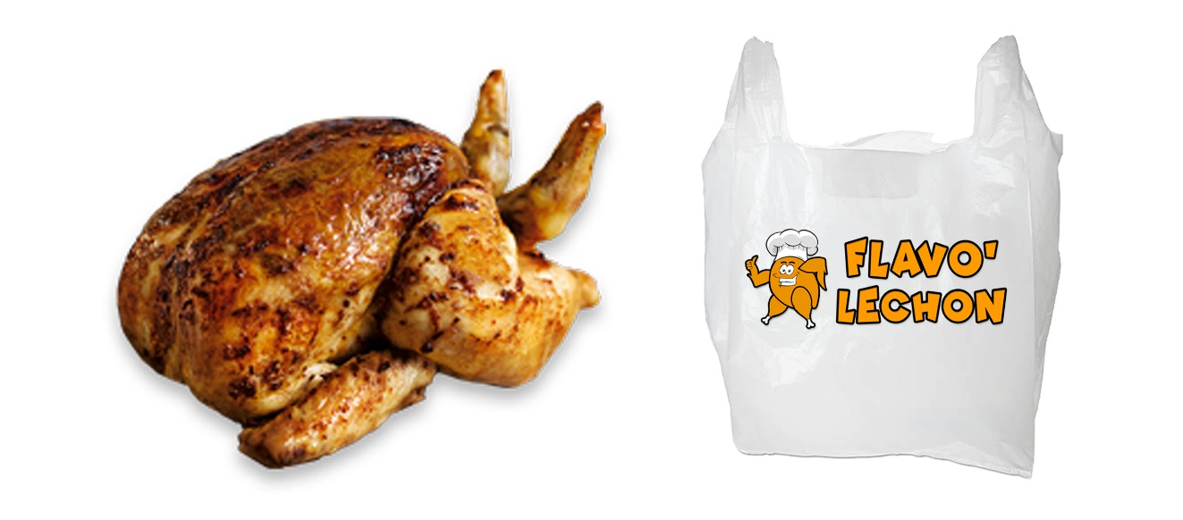
Figure 1.3. The Classic Lechon Manok and Packaging

- Barbeque
Another favorite way of preparation of chicken among Filipinos. The dressed chicken will be marinated overnight in a mixture of garlic, ground pepper, calamansi, soy sauce, oyster sauce, and banana ketchup. The chicken will be also glazed with more or less the same marinade during roasting to enhance the flavors and create the saucy exterior. The product is typically served without sauce but can be added with toyo-mansi or banana ketchup. The product is packaged with an orange plastic bag.
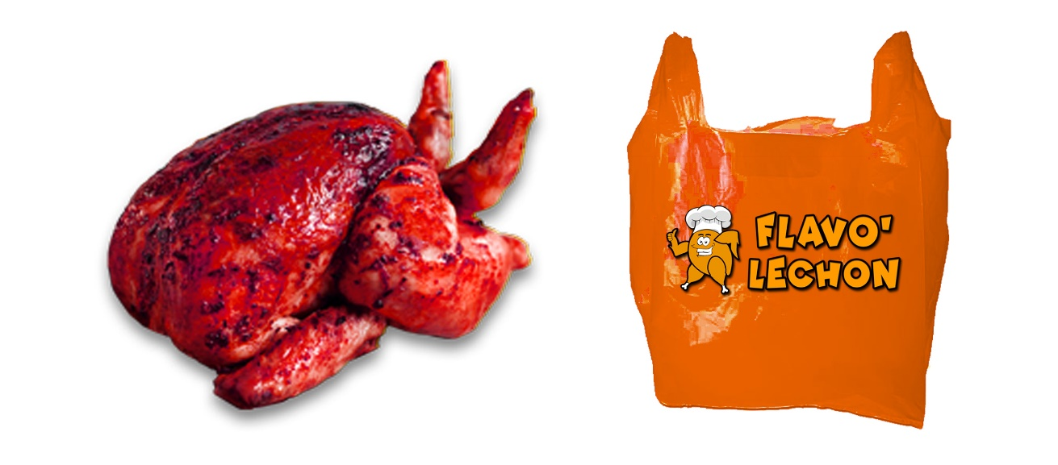
Figure 1.4. The Barbeque Roasted Chicken and Packaging

- Spicy
This product is based from the classic lechon manok prepared with hot and spicy ingredients. The chicken will be marinated with garlic, onion, brown sugar, salt and ground pepper, along with spices such as the siling labuyo native to the Philippines and chili paste. The product will be served with the classic lechon manok gravy.
The product will be packaged with a red plastic bag which symbolizes with the hot and spicy flavor of the roasted chicken.
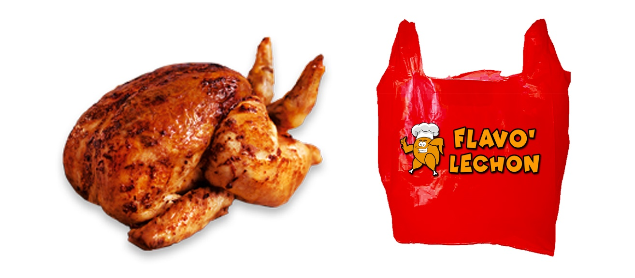
Figure 1.5. The Spicy Roasted Chicken and Packaging

- Curry
Famous for its various herbs and spices, the favorite spicy indian dish will be incorporated with the roasted chicken. The product is seasoned with coconut milk, curry powder, cumin, ginger, garlic, pineapple, peppercorns, and other spices.
The product will be packaged with a yellow-green colored plastic bag which resembles the main color of curry.
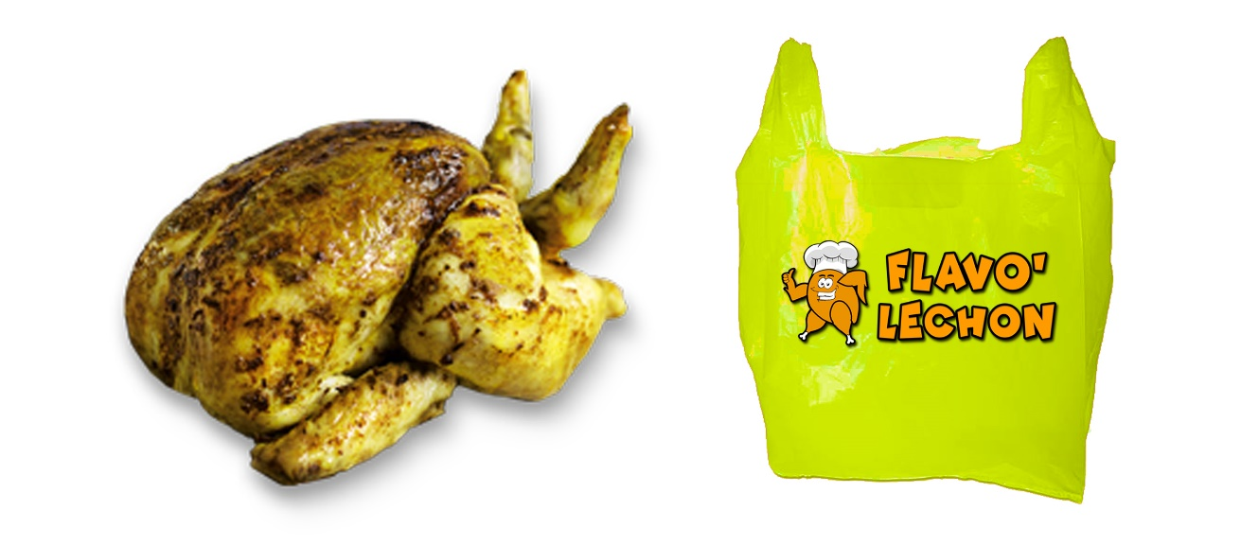
Figure 1.6. The Curry Roasted Chicken and Packaging

- Cheese-Stuffed
The delicious dairy food made from pressed milk curds. Cheese is often compatible with numerous dishes including chicken products.
This dressed chicken will be stuffed with cheddar and quickmelt cheese which is marinated beforehand in garlic, onion, brown sugar, salt, ground pepper, and small quantities of milk. The cheese stuffed roasted chicken will be served with a special homemade tomato sauce.
The product will be packaged with a bright yellow plastic bag to symbolize the color of the cheese.
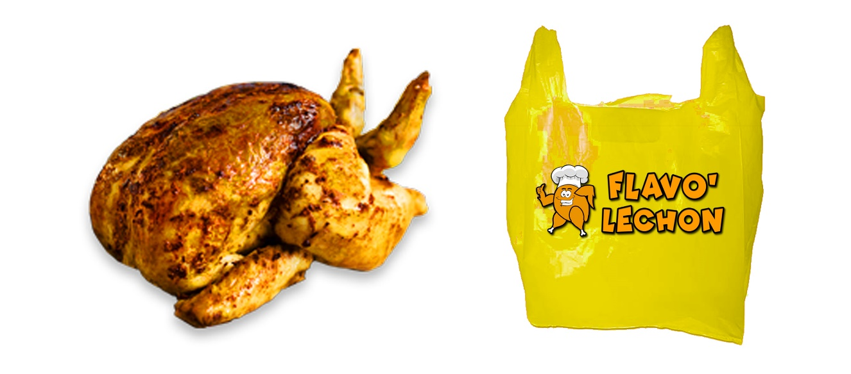
Figure 1.6. The Cheese Stuffed Roasted Chicken and Packaging

Aside from the health benefits that the customers can get from the consumption of chicken such as reducing stress, improving eye sight, and boosting immunity, the business can provide to customers the option to choose the different variants of roasted chicken which suits their tastes. Another benefit is that the business will give convenience by serving readily-available meals for takeout and delivery services (Organic Facts, n.d.).

Location Profile
The business will be located on Quezon Blvd., Malasiqui, Pangasinan in a building for rent with a total land area of around 30 square meters. The building is currently in the construction-in-progress stage in preparation for leasing and is owned by alias Mel. The proponents chose the first floor of the commercial building which is a good opportunity for the business to have more exposure in the market. The contract consists of three-month security deposit upon inception and a monthly rent of Php 17,000 thereafter.
Generally, the proponents chose the municipality of Malasiqui because it is one of the most populous town or city in Pangasinan, having more than 130,000 citizens according to the 2015 census of Philippine Statistics Authority. The researchers conducted further studies last July 3, 2017 of the area by looking into the present market of Malasiqui. The location is near to the public markets and supermarkets namely, Magic Warehouse and CSI Warehouse, where the business will source its inputs.
Malasiqui’s poblacion or town center is experiencing high commercial growth stimulated principally by high consumer spending. This is due to the increase in family incomes attributable to earnings of Overseas Filipino Workers (OFWs). In other terms, an increase in the number of OFWs, increases disposable income of every family in Malasiqui which also leads to an increase in consumer spending. The population in Malasiqui, as a percentage of labor force, of OFWs is approximately 22% which is one of the highest rates in the Philippines. The OFW phenomenon is a major factor in considering Malasiqui as the business location (Ortigoza, 2011).
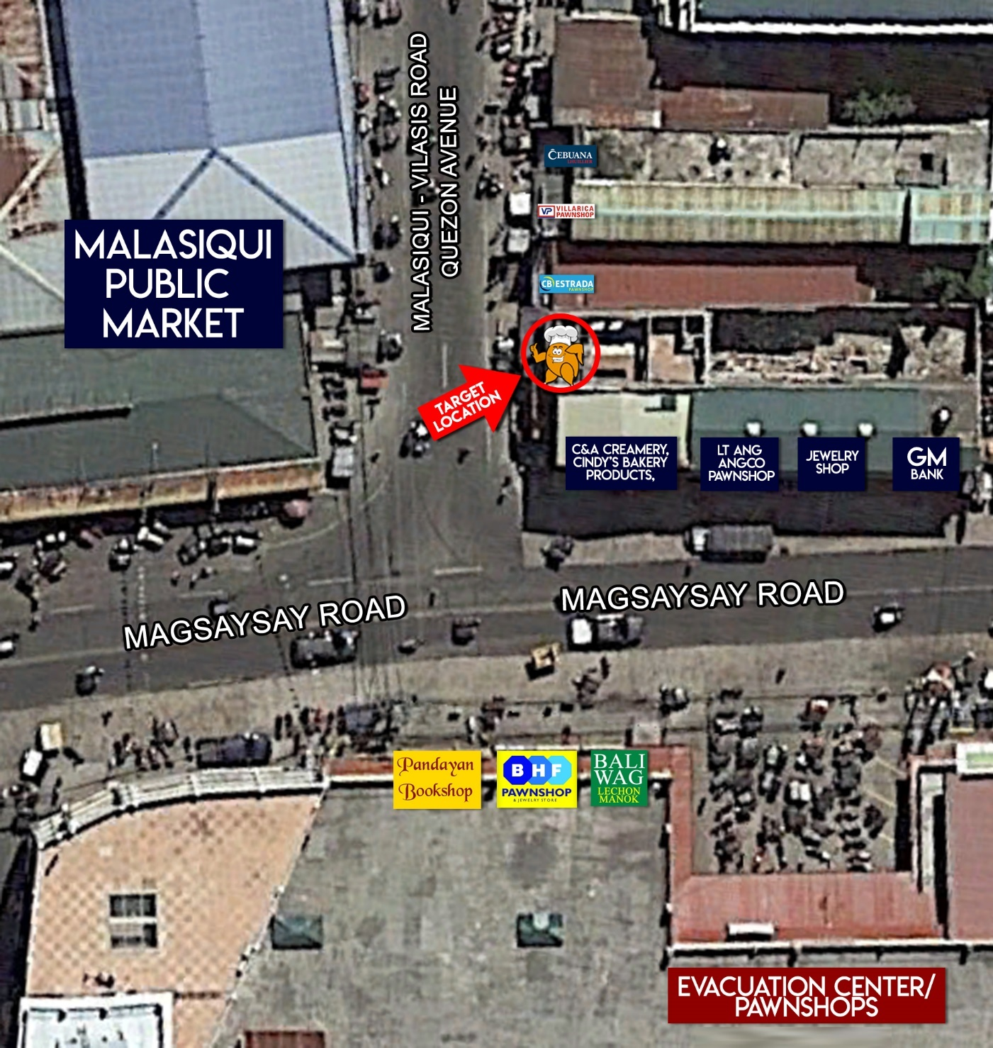
Figure 1.6. Location Map of Flavo’Lechon at
Quezon Avenue, Poblacion, Malasiqui, Pangasinan

SWOT Analysis

Strengths
- Variants of Roasted Chicken
The core strength of Flavo’Lechon is its variants of roasted chicken such as curry, spicy, cheese-stuffed and barbeque. Since most rotisserie stands offer the same classic lechon manok, offering these new products distinguishes the business from the competition. This first mover advantage will take the business ahead of others in terms of customer value. To maintain this core strength, the business would improve its supply chain and produce quality roasted chicken that is unmatched by the competitors.
- Delivery Services
The business will also offer additional delivery services for customers with bulk orders which will provide further convenience. This distinctive business feature will boost customer service as it provides customers, especially busy people, the flavored roasted chicken without going to the business premises. Thus, the distribution of the product will be spread out and consequenlty increase market share.
- Family Business Background
The idea of the business was derived from the family business of one of the proponents who have established a brand in Pangasinan. The knowledge of one of the proponents will provide a foundation in establishing the business by providing information about certain business specifics like supplier information, prices of inputs, prices of equipment, and other data that could be useful in establishing the business.

Weaknesses
- Perishable Materials and Products
The products, as well as its raw ingredients, are perishable. Therefore, in order to mitigate or prevent the loss due to the spoilage, ordering the proper amount to be purchased and produced is important. Also, proper marketing is important to encourage customers to buy the products to prevent the possible surplus in the supply.
Some of the marketing strategies and tactics that will be done include providing free tastes in malls near the area, as well as in the town proper. Next, the business can also use tarpaulins and posters to introduce the products to the bypassers and even give flyers to spread the idea about the company’s product. Finally, the business can also use the word of mouth marketing where satisfied customers may recommend the product to their friends and families.
- Control of Inputs
The raw materials needed for the product to complete are perishable, and since the required inputs are obtained outside the company, problem arises in controlling the quality of inputs necessary for production. Nevertheless, problem will be mitigated by planning ahead and maintaning proper amount of inputs needed to be obtained from suppliers.

Opportunities
- Vast Population in the Area
The business location is one of the most populous areas in Pangasinan. Malasiqui is ranked fourth in population within all of the cities and munipalities in the whole Region I, behind San Carlos City, Dagupan City, and the City of Urdaneta (Philippine Statistics Authority, 2016).
In addition to the previous, the business is just located across the public market and near terminals and bus stops as well. The vast population in the area will provide an opportunity for a bigger customer base in the area. The business will seize this opportunity to establish its brand by providing the customers with quality food that will attract customers, and keep them coming back.
- Accessibility
The location of the business is near the principal market where locals and travelers often gather to buy their needs. It is an effective way to make it easier for customers to get information about the business.
- Brand Franchising
Franchising is the granting of an exclusive right to a wholesaler or retailer to sell the brand manufacturer's product in a particular location. It is simply an opportunity for the business to expand in certain geographical area or location without tapping much of the business' own capital which will result to a higher financial returns with relatively little risk. Moreover, it can help the business to be known in different areas.
- Restaurant Partnership
One of the fastest growing businesses that are associated with two of the Four F’s (Food and Fun) is the restaurant industry (Villegas, 2017). The rise in the number of restaurants in the country gives the business an opportunity to penetrate this type of market segment. Partnering with restaurants could increase the sales and popularity of the product since it will be offered in the restaurant partnered. Hence, it serves as a bridge for establishing a good brand name and equity.

Threats
- Intense Competition
There are existing famous lechon manok brands such as Chooks to Go, Baliwag, Andoks, and Vin and Kris Lechon Haus in Malasiqui, so entering this market creates a threat for tough competition. Nevertheless, this threat can be minimized by having a competitive advantage by presenting variants of roasted chicken which are based on consumers’ preferences that competitors do not offer. Introduction of these variants will stimulate interest of the customers and may eventually avail the product. In addition, the business offers delivery services which adds value to the customers because it renders convenience in buying the business’ product in bulk.
- Buying Behavior
Some buyers are loyal customers. They prefer products which they are patronizing. Therefore, difficulty exists in encouraging the consumers to buy the business’ roasted chicken with variants of flavors because they would commonly hesitate to try new products and would instead stick to the products they used to buy. Therefore, the business will have to implement extensive promotional activities such as free tasting to introduce to them the tastes of the classic and flavored roasted chicken offered by the business.
- Easy to Imitate
If these variants are patronized by the customers, there are possibilities that the competitors or even new markets will copy these products. Thus, establishing strong customer relationship will minimize the possible danger that this may provide. These include building trust with customers, staying in regular contact with customers, good communication and accepting customer complaints or feedbacks. The business should also keep on continuously developing innovations taking into consideration the wants and needs of the customers.
- Chicken is Prone to Diseases
The chicken products from the suppliers are prone to disease such as bird flu which can lead to possible shortage in supplies, higher prices, or even distrust from consumers. In order to counter this, the business must establish a strong supplier relationship such as having a good payment discipline, which could prompt the supplier to offer cash discounts and stable prices in the long run. Shortage of supplies and distrust from customers are short term impact of chicken disease, therefore supply and demand is expected to return to normal later on (Nicavera, 2017).
Also, the business must also assure that the supplier have a Meat Inspection Certificate issued by the Meat Inspection Service which services as a proof that the products are safe and of good quality.
- Rising Input Prices
Rising input prices and other costs brought about by national market price, lack of government rules and regulations, export and import, and production cost will be a challenge for the business. In order to mitigate this, the business should negotiate to the supplier and ask for discount everytime placing an order. In addition, the business should buy only those necessary and enough materials or ingredients to eliminate the excess and waste.

Industry Overview

Industry Analysis
A study on meat production indicates that poultry is the fastest growing livestock sector worldwide. The Philippines has well-attained self-sufficiency in poultry, a prolific producer of poultry products. It has also a positive outlook for chicken industry because demand for chicken products is expected to increase along with the increase of population and income growth. The country’s supply continues to meet consumer demands in spite of rising population because of modernization and improvements that boosted the production rates (Poultry Infromation Network, n.d.).

Performance of Poultry Industry
- Production
Figure 2.1 Chicken Inventory by Classification, Philippines,
as of January 1, 2014 – 2016
Source: Philippine Statistics Authority
Figure 2.1 shows that as of January 1, 2016 the total chicken inventory was 178.77 million or 1.30% higher than the previous year with a 176.7 million inventory. Based on statistics’ breakdown of the 178.77 million total chicken inventory, it appears that the layer and native chicken went up by 3.04% and 2.87% respectively. However, the broiler chicken industry declined by 1.36%.
In terms of chicken production, it increased from 1,555,070 metric tons in 2013 to 1,571,762 metric tons in 2014, and 1,660,813 metric tons in 2015. A 1.07% and 5.67% growth rate in production in 2014 and 2015, respectively (Philippine Statistics Authority, 2016).
Philippine poultry market is composed of the food services, local markets, and households, which are mainly produced and supplied by broiler-producing industry. The study will focus on broiler chicken because it is the commercial chicken commonly seen in the markets. Considering the data above in the study will give sufficient information that supply of inputs to roasted chicken industry is adequate to support daily operation because of continuous increase in production and inventory of chicken.
- Consumption
Philippines is among the world’s fastest growing meat consumers. This can be observed from the hospitality and traditions of the Filipinos, such as the serving of food, especially meat, during celebrations like birthdays, wedding, holidays, or even when having visitors.
Chicken is one of the most served food on the table of every Filipino family. As a result, chicken meat (i.e. broiler meat) consumption continually rises over the years. Based on the statistics formulated by United States Department of Agriculture, there are around 1,451,000 metric tons of broiler chickens consumed by Filipinos in 2016. A decade ago, domestic consumption was just about 692,000 metric tons. Thus, growth rate was about 109.68% for the 10-year period (United States Department of Agriculture, 2017).
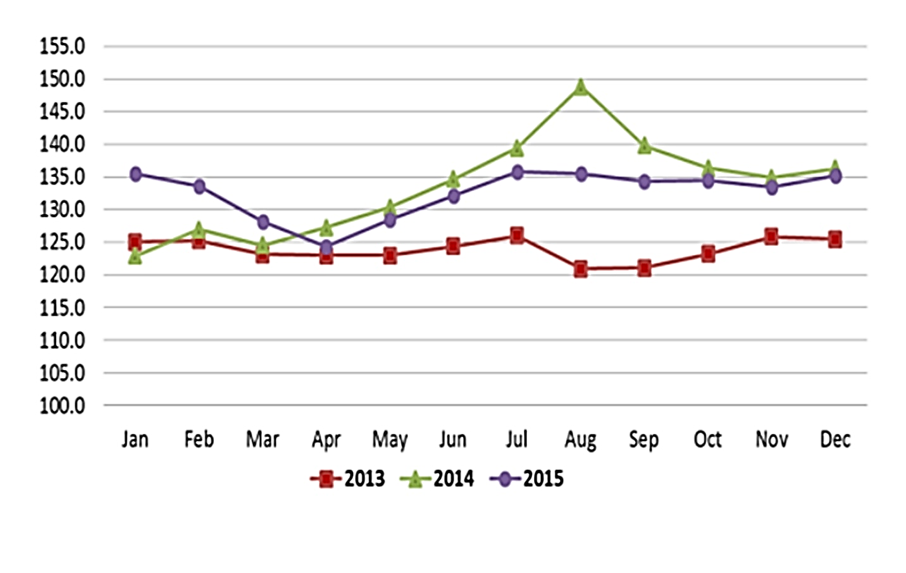
- Pricing
Figure 2.2 Monthly Retail Prices of Fully Dressed Broiler,
January to December, 2013-2015
Source: Philippine Statistics Authority
The price of commercial chicken fluctuates over time from 2013-2015 with the lowest average price of P121.00 per fully-dressed broiler in August 2013 and the highest average price of P148.00 per fully-dressed broiler in August 2014.
The graph indicates a volatility of the price of fully dressed broiler that will give rise to a higher risk in purchasing inputs for roasted chicken industry which may be mitigated by establishing and maintaining strong supplier relationship.

Future Prospects in Chicken Industry
Chicken meat is the second most popular meat in the Philippines, following pork. Research showed that over the period 1991-2004, chicken meat has the highest growth rate at 6.18% per annum, followed by pork and beef which is 3.49% and 3.39%, respectively. The demand for chicken products is increasing faster because of its many advantages, namely, lower prices, lower fat content, and the more convenient and versatile methods of meal preparation, as compared to other meats. However, demand for a product will also depend on its own price, the price of substitutes and complements, income of consumers, demographics and consumer preferences, as well as the occasional shocks to the system such as food-and mouth diseases and bird flu outbreaks (Chang, n.d.).
Issues and Problems Encountered
The commercial chicken industries are large scale, highly advanced, and geographically concentrated and integrated. Despite the advancement of technologies that greatly contribute to the increasing production rates, there has been a steady government regulations and consumer dissatisfactions that need to be addressed. Of particular concerns are the use of chemicals in feeds and animal protein, the impact on environment, animal welfare, and disease control.
Chicken Roasting Industry
Chicken roasting business is very popular business all over the globe. Since then, a lot of business enthusiasts see it as an opportunity to engage themselves into this kind of business. The sustainability of the business is just a matter of selecting a perfect spot that will lead to a higher market share; hence competition is not a big problem. Moreover, putting up this kind of business requires a capital ranging from Php500,000 to Php800,000.
In the Philippines, there are numerous chicken roasting businesses existing in different region. Among the well-known roasted chicken stalls are Ogis Lechon, Mr. Liempo, Mang Bok's Lechon Manok, Ang Lechon Manok ni Sr. Pedro, Uling Roasters, Baliwag's lechon manok, Andok's manok, and Chooks-to-Go. These businesses likely started with a small-scale production, but because of the significant return of investment, they have been operating successfully throughout the years and expanding several outlets around the country.
Baliwag Lechon Manok, which began operating in 1985, has grown to nearly 200 branches throughout the Philippines of which Quezon City has the highest number of outlets. From the simple lechon manok kiosk, the company founded restaurant and in the year 2000, Baliwag Grill and Restaurant was born. Likewise, Andoks also established its name in the chicken roasting industry and has now expanded in the specialty grocery store market, offering a host of products, including beer, an assortment of beverages, rice, sugar, and other grocery products. Another popular chicken roasting stand is Lechon Manok ni Sr. Pedro which has more than 300 branches nationwide. Finally, the Chooks-to-go is owned by Bounty Agro Ventures Incorporated (BAVI). Popular by the tagline “Masarap Kahit Walang Sauce”, Chooks-to-go is currently the number one in chicken roasting industry with more than one thousand outlets nationwide (8list, 2016).
The roasted chicken industry at the target location, Malasiqui, Pangasinan, features different rotisserie stands namely; Baliwag Lechon Manok, Chooks-to-go, Soriano-Nevado Familia, ACA Lechon Manok, Tonyong’s Lechon Manok and Liempo, Vin and Chris Lechon House and other local stalls. Despite the competition, the rotisserie stands are still profitable and sustainable given with the current demand for these products.

Supply
The supply of chicken in the Philippines still meets the demand of Filipino consumers despite the increasing population in the country. This indicates that there is sufficient supply of input particularly for rotisserie stands (The Meat Site, 2010).
Bounty Agro Ventures Incorporated (BAVI) – the group behind roasted chicken brands Chooks-to-Go, Uling Roasters, and Reyal, is selling approximately 200 million lechon manok per annum for these three brands nationwide. Considering the fact that this figure does not include yet other big rotisseries such as Baliwag, Andoks, Sr. Pedro, and other local rotisseries, there are more than 200 million roasted chickens that are being produced and sold in the country per year (Tomacruz, 2017).
The proponents conducted surveys and interviews last August 4, 2017 in Malasiqui, where Flavo’Lechon will be located. There are around six rotisserie stands in the town proper which comprises Chooks-to-Go, Baliwag, ACA, Tonyong’s, Vin and Chris Lechon Haus, and an unnamed rotisserie stand. However, there are also some rotisserie stands in some barangays in the municipality. The chicken rotisserie stands in Malasiqui produce and sell approximately 16,800 pieces of lechon manok per month, or 201,600 lechon manok per annum.

Demand
Roasted chicken or commonly known to the Filipinos as lechon manok is one of the Filipino favorites during special occasions. As stated earlier, there could be approximately more than 200 million roasted chickens that BAVI and other rotisserie stands in the country is producing, but the amount Filipinos consume per year can even be more than what the rotisseries can produce, which was patterned on the market trend in Malasiqui from the studies of the proponents as discussed in the succeeding paragraphs.
The proponents conducted surveys and interviews to the rotisserie stands in Malasiqui on August 4, 2017 and the results are depicted on Figure 2.3. It shows the production of each rotisserie stand, and the amount of shortages per day, and is multiplied to 30 days to come up with the roasted being produced in a month. The supply and shortage are then added to derive the consumer demand.
Based on the results of the interview of rotisserie stand employees, there are around 30-100 chicken that are being roasted and sold per day, but there are still around 10 people still searching for lechon manok in each rotisserie stand. Even though there are around 16,800 roasted chickens being produced in Malasiqui, it is still not enough to supply consumer demand of approximately 18,930 per month. Thus, demand of lechon manok is greater than what is being supplied and resulted to monthly shortage of approximately 2,130 roasted chickens.
Brand | Supply / Production | Shortage | Demand
Chooks-to-Go | 55 | 8 | 63
Baliwag | 55 | 8 | 63
Soriano's | *60 | 10 | 70
ACA Lechon Manok | 80 | 0 | 80
Tonio's Lechon Manok | 30 | 5 | 35
Vin and Chris Lechon Haus | 70 | 10 | 80
Others** | 210 | 30 | 240
Total per day | 560 | 71 | 631
Multiplied 30 days | x 30 | x 30 | x 30
Total per month | 16,800 | 2,130 | 18,930
*$\left[\left(\frac{40+50}{2}\right) ×\frac{5}{7}\right]+\left(100 ×\frac{2}{7}\right)$ - Soriano’s Production is 40 to 50 in weekdays and 100 in weekends the weighted average of the production.
**Six other rotisserie stands that averagely produce 30-40 units with around 5 shortages per day.
Note: Production on each rotisserie stand approximately doubles during Holiday Seasons.
Figure 2.3 Schedule of computation for Supply, Shortage, and Demand in units
of Roasted Chicken in Malasiqui, Pangasinan

In addition, the surveys also included matters regarding the residents’ and travelers’ preferences on flavored lechon manok. The results showed that approximately 84% of 50 respondents wanted to try new flavors of lechon. Since all of the rotisserie stands in the area offer the same classic lechon manok, some respondents said that it would be better if lechon manok will have other variants. However, some also said that they would be patronizing the products if they are satisfied with the taste of the lechon manok with its new flavors.

Porter’s Five Forces Model

Bargaining Power of Suppliers – MODERATE
The supplies needed for a chicken roasting business are dressed chicken, charcoal, ingredients and other spices. It also needs a rotisserie for the roasting process and a delivery vehicle for accommodating bulk orders. The suppliers of these materials can be found in Malasiqui, or if not, in its neighboring towns.
The supply for the dressed chicken can be available from three different sources, from wet markets, supermarkets, or from large chicken companies like Magnolia. Even though there are multiple number of suppliers, there are differences that can be observed such as the price of the chicken, capacity, and the consistency of the size and weight of the chickens.
Flavo'Lechon would likely choose Magnolia as its supplier because of its consistency in size and quality, and its ability to accommodate the company's expected purchases. The quality of Magnolia Chicken is different from those sold in public markets. However, it is not totally different from other large distributors. Therefore, Flavo'Lechon could still purchase almost similar quality from Swift, Vitarich, Tyson Agro-Ventures and Universal Robina. Switching costs that may be incurred will be as the result of disruption of operations due to changing suppliers. Therefore, the level of bargaining power of suppliers of dressed chickens is moderate.
On the other hand, the supply for charcoals and other ingredients are relatively easy to obtain in Malasiqui and nearby towns. There are several sellers of charcoal in Calasiao, and the company is planning to purchase from Charitos Trading. The supply of spices would be purchase from the public market of Malasiqui and supermarkets like CSI. The power of suppliers in this case poses less pressure on the business because the quality of these supplies in every market does not vary materially. Thus, the switching cost for charcoal and other ingredients is relatively low as compared to the chicken.
Overall, the bargaining power of suppliers for this kind of business would be because this presents many advantages MODERATE. The company could lower this by establishing and maintaining strong and steady supplier relationships, through creating a channel for consistent communication and always paying on time, such as reduced costs, price volatility mitigation, increased efficiency and continuous improvement.

Bargaining Power of Customers - MODERATE
Generally, being in the food industry presents a huge disadvantage in terms of bargaining power of customers. The main reason is that there are numerous competitors in the roasted chicken business, including two established brands, Chooks to Go and Baliwag.
There is also a considerable number of several substitutes, including those offered by large fast food restaurants and other food businesses not offering roasted chicken. Hence, there is ease for customers to switch from one brand or product to another.
The production costs of the roasted chicken could be easily estimated by customers because the prices of the main ingredients and materials used are publicly available through media and are comparable to the prices in the principal market.
On the other hand, since the target market is large and is expected to purchase in small quantities, this would lower the bargaining power of customers.
Altogether, the bargaining power of customers for this kind of business is MODERATE. To lower this, the business will utilize its variants to be distinguished from the competitors who only offer the classic lechon manok. This product differentitation strategy would create a perceived value among consumers and potential customers that may result into strength of the product in comparison to others. Also, this could make customers unfamiliar with the production costs and the process since it talks about products that are not currently offered in the market. In addition, these variants could potentially establish customer loyalty, given the positive outlooks from the proponents’ surveys, because of their uniqueness compared to other rotisseries.

Threats of New Entrants - MODERATE
Chicken roasting industry normally has low capital requirement. However, in the case of Flavo’Lechon, which offers flavors of roasted chicken and delivery services, cost to establish the said business becomes high. Starting up the business requires a capital investment of Php 500, 000 to Php 800, 000 which includes the rotisserie, signage, cooking materials, delivery vehicle, rentals, raw materials and other operating expenses. Therefore, this will be added to the barriers to entry.
Another barrier to entry is the use of proprietary knowledge or trade secrets since each business has its own distinct taste of their products. Flavo’Lechon has its own unique recipes for each flavor. These will serve as the trade secret for the business to prevent new entrants from identically copying the products offered.
On the other hand, economies of scale can be observed in processing the roasted chicken. The fixed costs such as depreciation from fixed assets and other manufacturing overhead will be spread out over a large number of roasted chicken produced. Increasing the number of production of roasted chicken will lead to a lower total fixed cost per unit and ultimately a lower average cost per unit. A proportionate saving in costs gained by an increased level of production will increase profitability which would give an incentive to people to venture in chicken roasting industry.
After assessing the given situations, the proponents believe that the barriers to entry are of the same force with the contrary. Hence, the threat of new entrant for this kind of business is MODERATE. To reduce the effects of the threats, the business would preserve the secrecy of its recipes by entrusting the critical preparations of the chicken to the key personnel or only a few trusted employees.

Threats of Substitutes - HIGH
Substitute goods are goods which may replace each other in use. Considering substitutes of the product will help the company evaluate customer behavior towards product price, quality and availability.
As for roasted chicken, there is plenty of substitutes because the food industry is wide. Substitutes of roasted chicken include pork, beef, and other meats that are prepared by frying, baking, steaming, smoking or grilling which can be made from fast food restaurants, and small eateries. These are considered substitutes since they are usually part of the choices of customers when considering food satisfaction and convenience in their meals. Basically, this high number of substitutes and low switching cost make the threat of substitutes HIGH.
However, relative to the substitutes, roasted chicken is much affordable and is best shared within the family members. A regular-size roasted chicken could feed at most 8 persons, thus, the cost per person would be a minimum of Php 25 when Php 200 per roasted chicken is used, as compared to Php 30 as the starting price per serving of meat in small eateries and fast food restaurants. This could end up attracting customers to buy roasted chicken rather than its substitutes.
Further, the strategy to add variants to the roasted chicken presents an opportunity for the company to better fulfill the needs of customers. Flavo’Lechon intends to provide more benefits to customers through adding flavors to the classic roasted chicken, while staying affordable. This lessens the threat of substitutes. Also, the products’ quality should continuously improve and remain sustainable in the long run in order to gain customer loyalty which will also mitigate the threat.

Competitive Rivalry Between Existing Players - HIGH
Competition in the market is inevitable. As the number of competitors increase, the rivalry between businesses intensifies. Thus, the struggle for market share among companies became tougher and more rigid which made them focused on differentiating their products and formulating strategies that enable them to amply grasp consumer demands
Flavo’Lechon will be operating in Malasiqui, Pangasinan where two well-known chicken roasting business (i.e. Chooks-to-Go and Baliwag) along with other small rotisserie stands are operating. Chooks to Go and Baliwag offers better quality than those small rotisserie stands, but charge customers a higher price of Php 230 – 250, as compared to Php 170 – Php 190 by the small local rotisserie stands. With exception to the said companies, the other rotisserie stands have low product differentiation caused by the similarities observed by the proponents in preparing the chicken for roasting. The price is also large determining factor for customers since there is not much of a difference in the products. This is noticeable in the demand for the roasted chicken, for which the demand of Chooks to go and Baliwag is lesser than those other rotisserie stands who offer lower prices. Therefore, the competition among these present players is intense and is relatively easy for the customers to simply move from one company to another.
Therefore, the competitive rivalry of the existing players is HIGH. Flavo’Lechon would take advantage of the competitive rivalry by introducing product differentiation to the market. The business will offer variants of the roasted chicken that will be significantly different from the competition. It is also part of the strategy of the business to offer high quality roasted chicken by preparing the chicken cleanly and appropriately, for a price neither too much nor less.
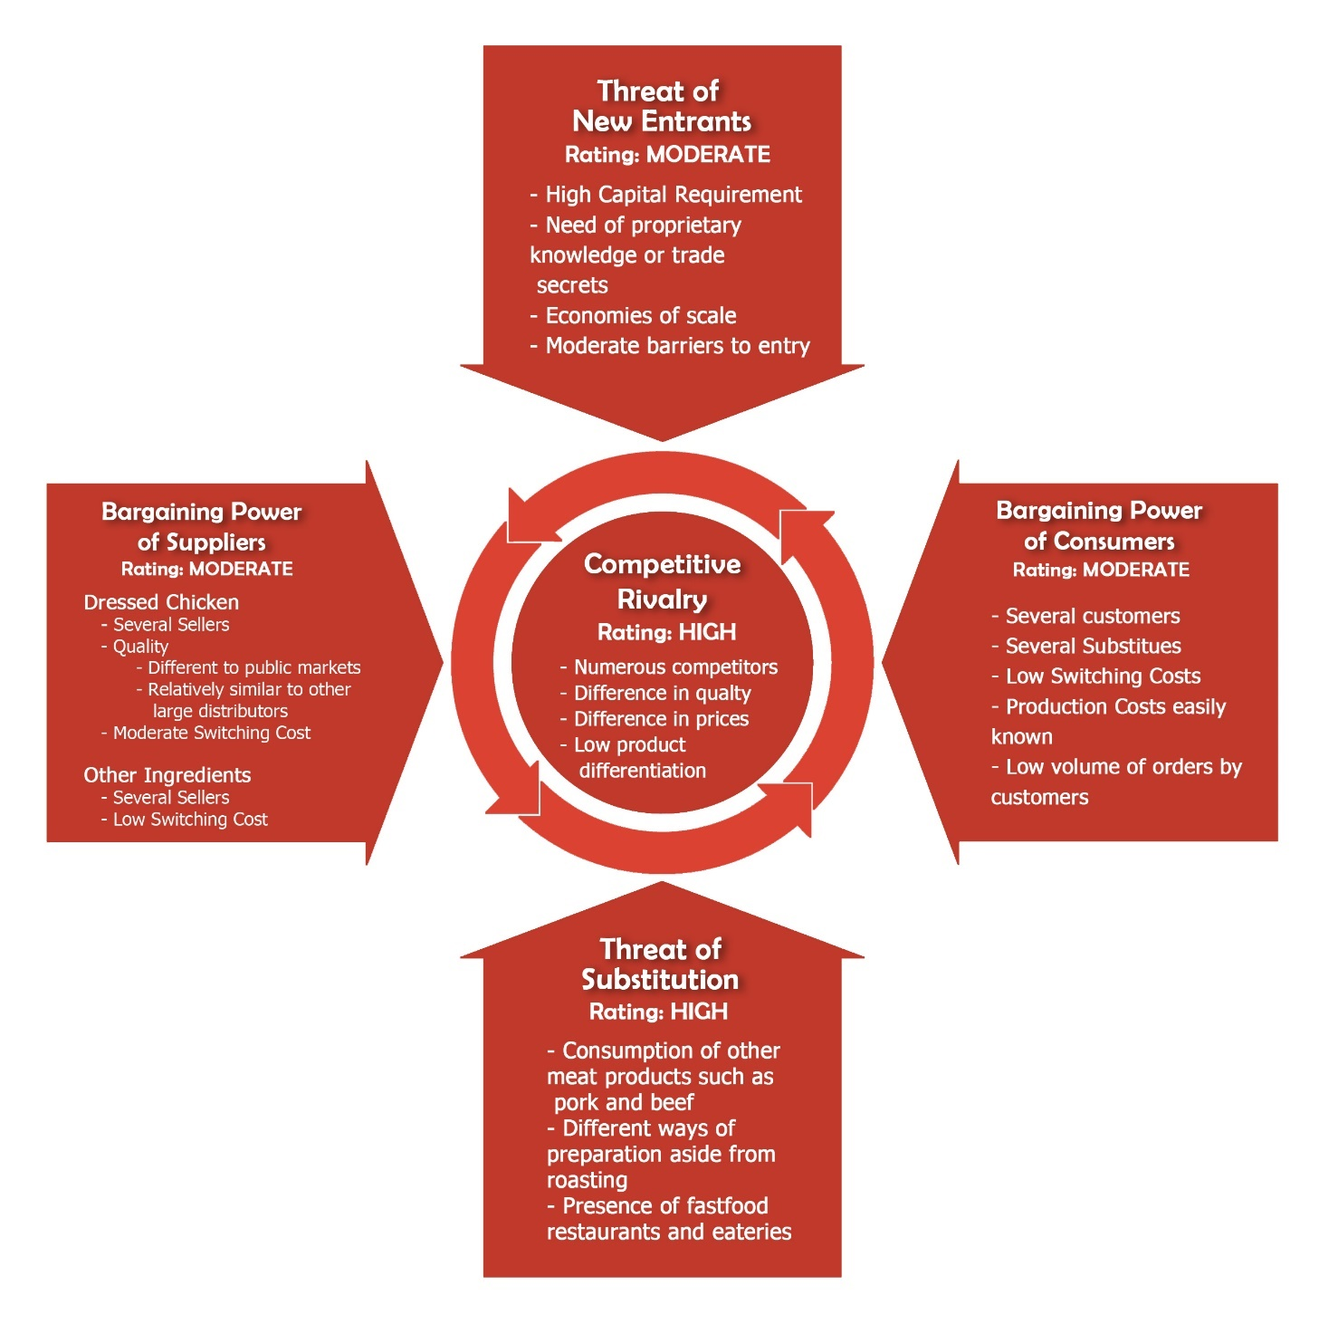
Figure 2.4 Porter’s Five Forces Model - Chicken Roasting Industry
Malasiqui, Pangasinan

Competitors’ Profile
- Baliwag Lechon Manok
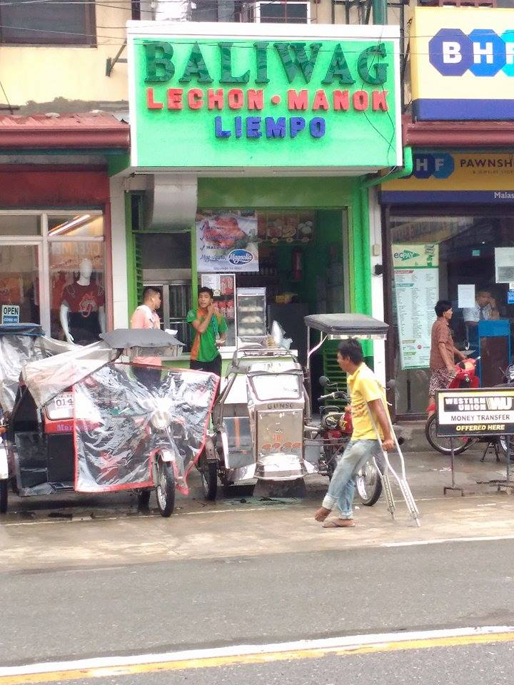
From a humble beginning, Baliwag Lechon Manok is now one of the top pioneers of roasted chicken in the Philippines. It started its operation on November 1985 at Project 8 Quezon City by Mr. Dwight and Mrs. Dolores Salcedo.
Currently, Baliwag Lechon Manok grown to nearly 200 outlets nationwide, one which is located at Malasiqui, Pangasinan franchised by Mr. Rodelio Marquez on May 13, 2017. In the said outlet, the business is producing and selling approximately 60 roasted chickens with an excess demand of 5-10 roasted chicken per day. The selling price is Php. 235.00 per roasted chicken. Moreover, Baliwag also offers pork-barbeque, siopao, bottled atsara and their version of crispy, juicy fried chicken.
Figure 2.5 Baliwag Lechon Manok in Malasiqui Pangasinan
The competitive advantage of Baliwag is that the resellers or franchisees have limited idea about the ingredients and processes used in marinating the chicken which make the recipe secrets and difficult to imitate.
- Chooks-to-Go
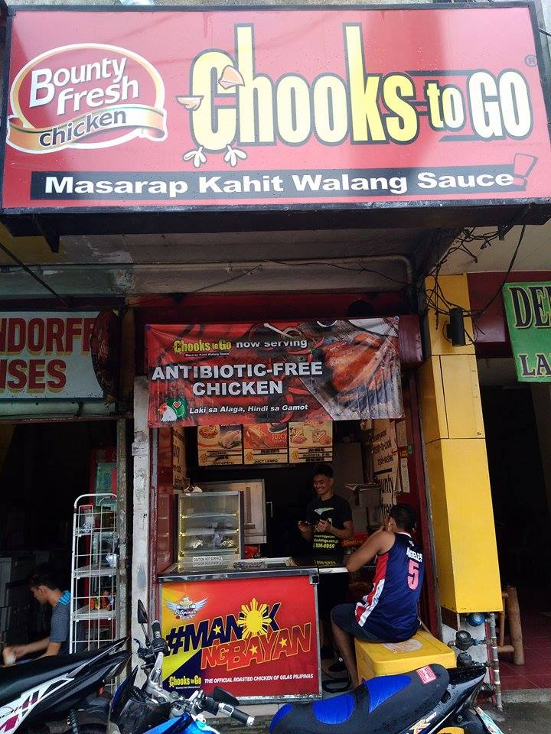
Chooks-to-Go is a chain of stores owned by Bounty Agro Ventures, Inc. (BAVI), a privately-owned company operating in the Philippines, headed by their President and General Manager Mr. Ronald R. Mascarinas. The company concept was first started in June of 2008 introducing their juicy, absolutely tasty oven-roasted chicken to every major nook and corner of the country.
The company offers roast chicken and processed meats for off-premise consumption and is the largest roasted chicken retail business in the country which has close to a thousand stores including the one located at Malasiqui, Pangasinan. The staff of Chooks-to-Go they produces 50-60 roasted chickens every day for a price of Php. 230.00 each.
Figure 2.6 Chooks-to-Go Rotisserie Stand in Malasiqui, Pangasinan
What makes Chooks-to-Go one step ahead from its competitors is because of the taste and the quality of their roasted chicken which is really delicious even without sauce. The company’s tagline, “Masarap Kahit Walang Sauce”, made Chooks-to-Go a popular roasted chicken brand. Their mission is to provide freshly cooked food of the best value in every neighborhood.
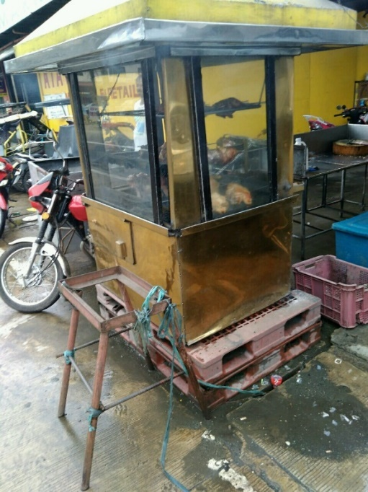
- Soriano-Nevado Familia
Soriano-Nevado Familia is a rotisserie stand initiated by Mr. Reynaldo G. Soriano on May 23, 2003 at Poblacion, Malasiqui, Pangasinan.
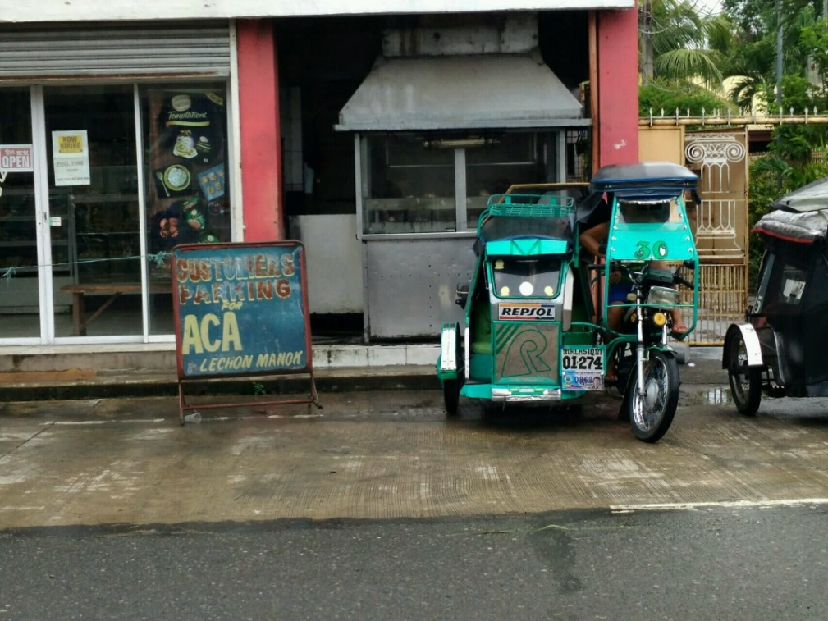
Despite of lack of customers’ awareness about the brand, Soriano-Nevado Familia able to produce and sell 60 roasted chickens per day. This is due to cheaper price compare to Baliwag Lechon Manok and Chooks-to-Go, which is Php. 170.00 per roasted chicken. In addition, the business is also offering liempo worth Php 100.00 as an alternative for roasted chicken.
Figure 2.7 Soriano-Nevado Familia Rotisserie Stand in Malasiqui, Pangasinan
- ACA Lechon Manok
One of the oldest businesses in Poblacion Malasiqui, Pangasinan is ACA Lechon Manok which started year 1997. Because of its established name and long existence in the industry, the business gains a huge number of customers.
Figure 2.8 ACA Lechon Manok Rotisserie Stand in Malasiqui, Pangasinan
In the interview conducted last August 4, 2017, ACA Lechon Manok is currently producing and selling 80 pieces of roasted chicken per day. Other than the established name, one of the reasons why ACA is making a highest sale is because of its cheaper price worth Php170 per roasted chicken.
Lastly, for 20 years they already build a strong commitment with the customers which make them standout from other rotisserie stands in Malasiqui.
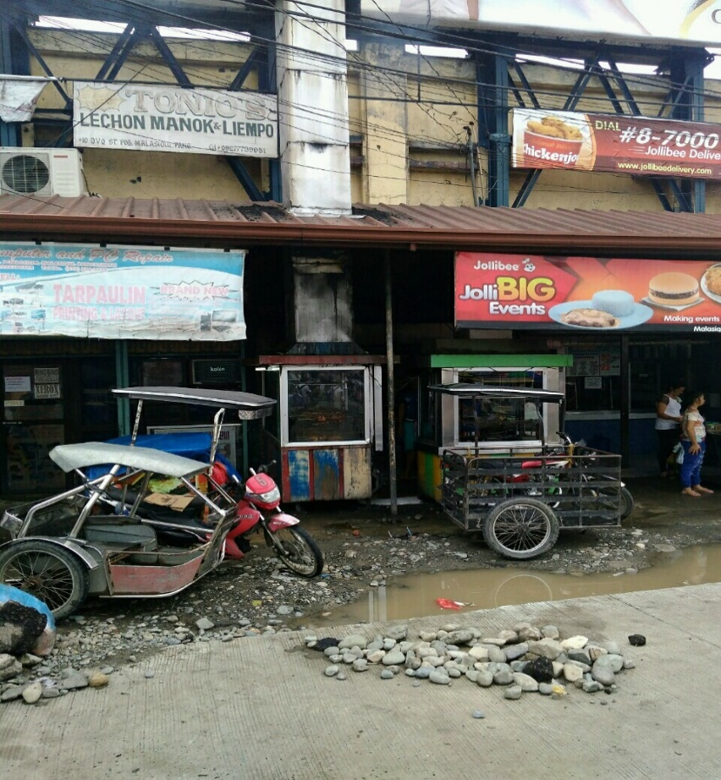
- Tonio’s Lechon Manok and Liempo
Started in year 2007, Tonio’s Lechon Manok and Liempo is currently one of the retail business in Malasiqui which offers a readily-available roasted chicken and liempo.
Figure 2.9 Tonio’s Lechon Manok and Liempo Rotisserie Stand in Malasiqui, Pangasinan
For ten years of existence, the business is producing and selling 30 pieces of roasted chicken per day worth Php 170.00 each. As compare to other rotisserie stands, Tonio’s Lechon Manok and Liempo has the lower number of roasted chicken sold per day. The reason why they have lower sales is because of lack of brand awareness due to many competitors operating in Malasiqui. Moreover, the quality of their product is lower than the other rotisserie stands, such as Chooks-to-Go and Baliwag, because the business is focusing in reducing cost and selling the product at cheaper price at the expense of its quality.
- Vin and Chris Lechon House
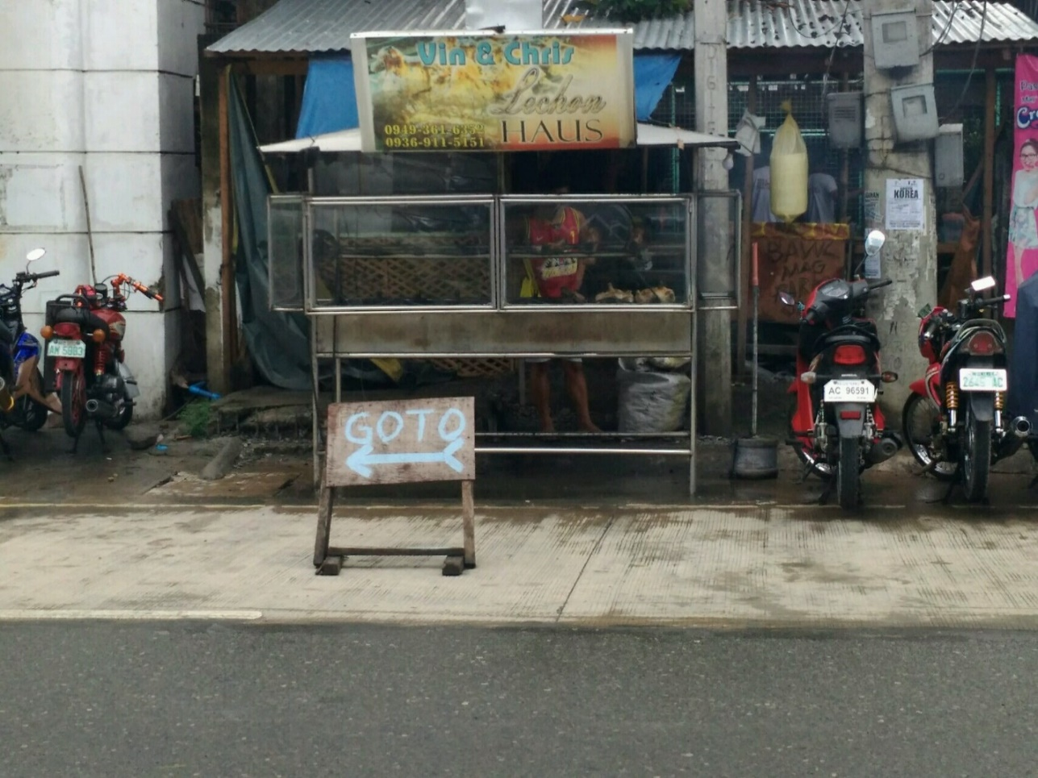
After more than ten years in the food industry, Vin and Chris Lechon House has been one of the best retailers of roasted chicken in Malasiqui, Pangasinan.
The business is producing and selling 70 roasted chickens per day with an excess demand of 10 roasted chickens. The reason why they gain this high number of product being sold is because of the quality of their product given a low selling price of Php. 170.00. Moreover, their long-term relationship with their suppliers and customers made them standout from other local rotisserie stands in Malasiqui, Pangasinan.
Figure 2.10 Vin and Chris Lechon House Rotisserie Stand in Malasiqui, Pangasinan

- Other Local Rotisserie Stands
Aside from the retailers of roasted chicken mentioned above, there are still six rotisserie stands which are competing in the market of Malasiqui, Pangasinan. The table below shows the owner of rotisserie stand, the location and the date the business was initiated.
Name Of Entrepreneur | Date of Establishment | Address
Mrs. Anita C. Garcia | January 1, 2006 | Poblacion, Malasiqui, Pangasinan
Mr. Joelito Pata | January 1, 2003 | Poblacion, Malasiqui, Pangasinan
Mr. Howard Macaraeg | 2006 | Poblacion, Malasiqui, Pangasinan
Mr. Jesus P. Reyes | January 1, 2007 | Guilig, Malasiqui, Pangasinan
Mr. Eric Brian A. Domantay | January 9, 2009 | Poblacion, Malasiqui, Pangasinan
Mrs. Shirley B. Inaldo | October 24, 2016 | Lunec, Malasiqui, Pangasinan

These rotisserie stands are producing and selling 30-40 roasted chickens per day with an excess demand of 5-10 pieces. Moreover, their customers are mostly those consumers who are looking at the price instead of the quality of the product. In addition, the proponents observed the way they prepare the products and found out that some owners are not making effort in marinating the chicken. They are just roasting the chicken without any flavors that make it tasteless. However, the price of their product, which is Php. 160.00- 170.00 each, gives them an advantage in order for them to continue their business.

Supplier’s Information
Poultry Farming is the ultimate source of chicken meat and eggs. Broiler chickens are chickens that are farmed for meat, while Layer chickens are farmed for their eggs. According to Malasiqui’s one-stop information center, there are currently eight poultry farms that are registered at Malasiqui Pangasinan. The following table identifies the owner and location of those poultry farms
Owner | Location
Brignoli H. Barinos | Brgy. Pamaranum
Orlando V. Soriano | Brgy. Canan Norte
Edwin Agbuya | Brgy. Bacundao East
Cesar A. Tamayo | Brgy. Lareg Lareg
Alfe M. Soriano | Brgy. Palapar Norte
Marita Sandiego | Brgy. Palapar Norte
Carlos Dela Reyna | Brgy. Nancapian
Jason T. Domantay | Brgy. Bongar

While these can be the potential supply for the business, the proponents found on August 23, 2017 that these poultry farms are contracted by Magnolia, a subsidiary of San Miguel Corporation. These poultry farms do not directly deliver to businesses. The options for the supply of dressed chicken can be classified into three sources: public wet markets, supermarkets, and directly from huge companies.
- Public Wet Market
The first option for the supply is public wet market, where it is located at Poblacion, Malasiqui, Pangasinan, just across the target location of Flavo’Lechon. There are currently 10 stalls that offers whole dressed chicken for sale namely; Rodney and Anne Meat Shop, Thelma’s Meat Shop, Ramos Meat Shop, Perla Meat Shop, Connie’s Meat Shop, Jay Vic Meat Shop, Annie De Vera David Meat Shop, Green Fields Meat Shop, DadongSulit Meatshop and Kambal Meat Shop. All of these stalls offer chicken at a list price between Php130.00 to Php140.00 per kilo as of August 25, 2017.
Strengths of the public wet markets are the suppliers’ proximity to the business, and prices are negotiable and subject to trade discounts. Weaknesses are the dressed chicken may not be readily available in bulk in the required time, and the weights of chicken may vary from supplier to supplier if the business were to purchase from different stalls.
- Supermarkets
The second option for the supply are the supermarkets. There are two supermarkets located at the town namely the CSI Warehouse, and Magic. Both of the supermarkets supply Magnolia Chicken with a list price of Php135.00 as of August 25, 2017.
Strengths of the supermarkets are the suppliers’ proximity to the business, and food handling and preparation is very clean. However, the weakness is that prices are non-negotiable and fixed.
- Food Companies
At present, there are five food companies that supply 80% of the Philippine demand for poultry and poultry products namely, Magnolia Chicken which is under San Miguel Corporation, Swift Foods Inc., Vitarich Corporation, Tyson Agro-Ventures and Universal Robina Corporation (Regional Board of Investments, n.d.). The business can able to get its supply of dressed chicken through partnering with these five companies. Strengths involve the supply is available in bulk, prices are negotiable and lower than those in the wet market by as much as Php 3.00.
The chosen medium of supply by the proponents is through these huge companies specifically Magnolia Chicken, as this gives Flavo Lechon a constant supply of dressed chicken which is available at huge quantities, ease of convenience through delivery, consistent high quality of products, and lower cost per unit due to trade discounts.

Review of Related Literature

Filipinos are fond of eating food adventurously to explore different styles of cooking patronized by the public. Vegetables and fruits alone cannot fully satisfy regular customers; hence, a certain type of meat comes with a standard course of meal. Favored by almost nine out of ten Filipinos, one of the timeless trends within the food industry is the roasted chicken or often called lechon manok in the Philippines. Roasted chicken is a grilled product which used chicken as its meat to be heated or cooked over a bunch of charcoals (Lechon Business Oppurtunity, 2014).
An example of a currently successful chicken roasting business, Andoks, has established its name not only in chicken roasting industry but also in the food industry as a whole. It effectively became a pioneer in chicken retail business as it continues to operate in three major regions of the country - Luzon, Visayas and Mindanao. This is considered as an evidential matter about the booming industry of roasting (Andok's, n.d.).
Competition is not a big problem with regards to starting a chicken roasting business. The reason behind is the persistent establishment of an ideal place for growth to maintain business sustainability. Expenses and other several income deductions can therefore be covered or exceeded by the significant return of investment.
Another factor of building own chicken roasting business is its never dying source of supply and demand. The essential wants of the state and poultries across the Philippines is taken into account for an additional production of chicken every year. Furthermore, the need for chicken of existing grillers in the Philippines is considered together with the demand of the huge Philippine restaurants like Jollibee, Mang Inasal, and Kenny Rogers. Thus, the supply of chicken adds to the strength of the said food commerce business.
The demand on the other hand has always been a good opportunity for a business that offers product that has become a symbol of camaraderie. Roasted chicken will never miss several occasions of Filipinos from birthdays to just simple dinner or lunch. That is why chicken roasting business is a decent choice in searching for a long-term type of business; it just never gets old.
The roasted chicken industry has become a very popular business throughout the globe. According to President Ron Paul of Technomics Inc., a restaurant consulting firm in Chicago, roasting has a great potential for chicken business. In fact, many restaurants offering only fried chicken such as Kentucky Fried Chicken, Kenny Rogers and Boston Chicken expanded their market into non-fried chicken which includes roasted chicken. The expansion caused them to have substantial increase on their sales. Based on the National Restaurant Association, sales of fried chicken have grown an average of 3.5 percent annually since 1989 while 10.75 percent for non-fried chicken in the same year (Collins, 1995).
John M. Cranor, the president and chief executive of KFC said that “Fried chicken is our bread and butter and will continue to be for many years to come. But we strongly believe that, by the end of the decade, sales of non-fried chicken -- including rotisserie chicken -- may equal sales of our fried chicken." Truly, what he said proved that rotisserie chicken gives lot of opportunities to businessmen (Gold, 1993).
In the United States, some big businesses such as top supermarkets sell their roasted chickens at a low cost that profit very little to no money at all. These roasted chickens serve as a “loss leader” in which it is used to profit from other items that the shoppers will pick up once they are on the store. Costco, one of the largest chain of supermarkets in Northern America, pulls this trick to attract customers in the late afternoon on the weekdays where most people do their dinner plans. Costco’s strategy is that they do not put the roasted chicken stands in front of their stores, but instead the customers must first walk past through items such as flat screen TVs, smartphones, and blenders before reaching through the roasted chicken stalls. The shoppers who would want to stop at Costco to buy a roasted chicken really quick and hot, might walk past through the laptops and say “Maybe I will go to the Costco to buy a laptop for my son this Christmas” (Klein, 2016).
One good example of why roasted chicken business is good to be put up in the Philippines and other parts of Asia, is the case of Kenny Rogers Roasters, a chicken-based restaurant launched by Kenny Rogers and former KFC owner John Y. Brown, Jr in 1991. The business went bankrupt in 1998, but now enjoys its second life with more than 140 outlets after taking a trip across the Asian countries, especially on Malaysia and Philippines where its presence is strongest. Kenny Rogers Roasters which was once an obsolete, tarnished, or dying US brand, now is having a better and robust life in Asia and is being described as one of the fastest growing restaurant chains along the Pacific Rim (Brenhouse, 2011)
Several roasted chicken businesses here in the Philippines have been successful in their operations using their own edges to win over customers. 8list.ph identifies 8 well-known roasted chicken stalls that save "walang ulam" days. First is the Ogis Lechon with its sauce comprised of toyo, suka, calamansi and sili. Another would be Mr. Liempo, that is famous for its liempo and its tender, flavorful and classic lechon manok. Next would be the Mang Bok's lechon manok with intensely charred skin together with sweet and sour sauce. Also, there is Sr. Pedro lechon manok which is known for its good taste because of lemon grass. Next is Uling Roasters that offers an option with more inasal flavor. Another is Baliwag's lechon manok that blends two well-loved Filipino Flavors, inasal and barbeque. Further, there is Andok's manok with its fresh flavor of calamansi in its marinade along with its sweet-peppery sauce. Lastly, there is Chooks-to-Go with its theme of 'masarap kahit walang sauce' because of its sweet, peppery, and juicy flavor that people won't be looking for sauce. (8list, 2016)
Chooks-to-Go reached its peak of success due to its unique taste. It has taken an innovative brand position as the only ready to eat chicken that is sold without sauce.
Ronald Mascarinas described Chooks-to-Go’s roast chicken as “a bit sweet, like a sweet ham”. With this, Chooks-to-Go has overtaken well established rivals such as Andoks, Senior Pedro and Baliwag. He also added that the other businesses offer roast chicken with a salty taste.
In addition, Mascarinas believes that the driving force for a long-term retail success is consistent product quality and service. This is the reason why the company established the Bounty Agro Ventures (BAVI) Academy, an in-house-training team to do training for Chooks-to-Go personnel in customer service, rotisserie operation, equipment maintenance and leadership development (Poultry World, 2013).
Starting a chicken rotisserie restaurant requires low college degree or special skills involved. However, prior experience in restaurant or fast food field can give an advantage.
The steps on how to start a rotisserie chicken restaurant. First, planning the business by establishing a written outline or plan that lists all the items needed is essential in opening the business, as well as the estimated cost of each item in order to determine the amount of funds that need to secure.
Second, secure financing of the business by determining current savings, investments, and retirement funds to assess if additional funding is needed. Additional funds may be available through loans from banks or securing a business partner.
Third, find a location. Start out by checking locations of previously housed restaurants, bars, or other eating establishments. Moreover, it is important to know in advance whether to lease or buy.
Fourth, partner with food suppliers that will provide the inputs especially the chicken, sauces, seasoning, and other resources needed. It will also require the business to secure equipment for their operations.
Fifth, determine what role of management team will play in the day-to-day operations, if any. Recruit, train, and hire candidates if needed to fill up the positions vacant.
Lastly, utilize different marketing strategies to spread the word and give consciousness to market about the business (Dodge, n.d.).
Philippines is one of the top 10 countries which has the highest continuing growth rates when it comes to meat consumption which was predicted to be 30 percent annually from 2011 to 2021, based on an article in inquirer. This indicates that there is a great opportunity for the poultry industry in the Philippines (Salazar, 2016).
The Philippines has achieved self-sufficiency in the production of poultry products. With the use of modern technology, poultry farms in the Philippines were able to boost their production rate. Intensive systems attempt to make farming more “efficient” that results in cheaper finished product but they also need to take into consideration those hidden costs (Nowland, 2016). As a result, there are around P100-billion industry producing and about 800 million broilers that are being produced annually which, despite the increasing population of the country, is still being able to meet each consumer’s demand. However, there are exceptional years where shortage of supply occurs, which usually comes in the month of December, or when there are natural calamities where the industry is being affected that leads to poor growth or higher mortality rate. However, there are also challenges that the poultry industry in the country. One of which is the volatility in the prices of the major components of feeds such as soybeans, corn, and wheat, that has increased rapidly over the years (Pe, 2014).
In addition, the Philippine Statistics Authority concluded that Southeast Asian nation has sustained livestock production last 2015 despite the devastating effect of El Nino. In fact, chicken production grew by about 8.77% in the same year (Far Eastern Agriculture, 2015).
The concept of adding different flavors of roasted chicken aside from the classic flavor, was one of the reason behind the success of Tiktilaok, a grilled chicken food chain established by Frederick L. Cortes. The business started following what other roasted chicken vendors did including its flavor, but then it failed. Realizing this, Cortes started reinventing his brand by making something different from other vendors. The business went to malls rather than streets; sold one-half and one-fourths of the chicken rather than just one whole; and of course it added flavors to its products. From a single outlet, the business grew about 24 outlets and has planned more expansions. The flavors offered were honey roasted, garlic, hot and spicy and special (Yap, 2012).

References
8list. (2016). 8 Lechon Manok Stalls that Save “Walang-Ulam” Days. Retrieved from 8list Web Site: http://8list.ph/lechon-manok/
Andok's. (n.d.). Our Story - Andok's. Retrieved from Andok's Web Site: http://andoks.com.ph/about-us/
Benwick, B. S. (2012, October 30). The bird that goes around, stays around. Retrieved from The Washington Post Website: https://www.washingtonpost.com/lifestyle/food/the-bird-that-goes-around-stays-around/2012/10/29/e1509d2c-073c-11e2-a10c-fa5a255a9258_story.html
Brenhouse, H. (2011). The Secret Second Life of Kenny Rogers Roasters ... in Asia. Retrieved from TIME Web Site: http://content.time.com/time/world/article/0,8599,2084444,00.html
Chang, H.-S. (n.d.). Analysis of the Philippine Chicken Industry: Commercial versus backyard sector. Retrieved from Age Consearch Web Site: http://ageconsearch.umn.edu/bitstream/165854/2/AJAD_2007_4_1_4Chang.pdf?fref=gc
Collins, G. (1995). Boston Chicken Bets on Manhattan. Retrieved from The New Your Times Web Site: http://www.nytimes.com/1995/05/12/business/boston-chicken-bets-on-manhattan.html?mcubz=0
Dodge. (n.d.). How to Start a Rotisserie Chicken Restaurant. Retrieved from Chron Web Site: http://smallbusiness.chron.com/start-rotisserie-chicken-restaurant-30770.html
Far Eastern Agriculture. (2015). Philippines poultry production sustains despite El Nino. Retrieved from Far Eastern Agriculture Web Site: http://www.fareasternagriculture.com/live-stock/poultry/philippines-poultry-production-sustains-despite-el-nino
Gold, D. M. (1993). Big Bets on Roasted Chicken. Retrieved from The New York Times Website: http://www.nytimes.com/1993/10/17/business/big-bets-on-roasted-chicken.html?pagewanted=all&mcubz=0
Isla, C. (2015, June 7). Sa sabong ng mga litson manok, kanino ka tataya? Retrieved from GMA News Online Web Site: http://www.gmanetwork.com/news/publicaffairs/content/500026/sa-sabong-ng-mga-litson-manok-kanino-ka-tataya/story/
Klein, K. (2016). Are Rotisserie Chickens a Bargain? Retrieved from Price Onomics Web Site: https://priceonomics.com/are-rotisserie-chickens-a-bargain/
Krasner, D. a. (2007). The new outdoor kitchen: cooking up a kitchen for the way you live and play. Singapore: The Tauton Press.
Lechon Business Oppurtunity. (2014). How to Franchise a Business in the Philippines as an Overseas Filipino Worker? Retrieved from Lechon Business Oppurtunity: https://lechonbusinessopportunity.wordpress.com/category/lechon-manok/
Nowland, D. (2016). The truth about the chicken industry. Retrieved from Jaime Oliver Web Site: http://www.jamieoliver.com/news-and-features/features/truth-chicken-industry/
Organic Facts. (n.d.). 7 Impressive Benefits Of Chicken. Retrieved from Organic Facts Website: https://www.organicfacts.net/health-benefits/animal-product/health-benefits-of-chicken.html
Ortigoza, M. C. (2011, October 31). OFWs perks up economy in Malasiqui. Retrieved from P'NAN NEWS: http://wwwmortzcortigoza.blogspot.com/2011/10/ofws-perks-up-economy-in-malasiqui.html
Ortigoza, M. C. (2011). OFWs perks up economy in Malasiqui. Retrieved from P'NAN News Web Site: http://wwwmortzcortigoza.blogspot.com/2011/10/ofws-perks-up-economy-in-malasiqui.html
Ortigoza, M. C. (2011, October 31). P'NAN NEWS. Retrieved from OFWs perks up economy in Malasiqui: http://wwwmortzcortigoza.blogspot.com/2011/10/ofws-perks-up-economy-in-malasiqui.html
Pe, R. (2014). How big is the Philippine poultry industry? Retrieved from Inquirer Web Site: http://business.inquirer.net/165020/how-big-is-the-philippine-poultry-industry
Philippine Statistics Authority. (2016). Chicken Industry Performance Report. Retrieved from Philippine Statistics Authority Web Site: https://psa.gov.ph/sites/default/files/CHICKEN%20Industry%20Performance%20Report%20-%20Jan%20-%20Dec%202015_1.pdf?fref=gc
Philippine Statistics Authority. (2016). Population of Region I - Ilocos Region. Retrieved from Philippine Statistics Authority Web Site: https://www.psa.gov.ph/population-and-housing/title/Population%20of%20Region%20I%20-%20Ilocos%20Region%20%28Based%20on%20the%202015%20Census%20of%20Population%29
Poultry Infromation Network. (n.d.). Industry Status - Chicken. Retrieved from Philippine Council for Agriculture, Forestry and Natural Resources Research and Development Web Site: http://www.pcaarrd.dost.gov.ph/home/momentum/poultry/index.php?option=com_content&task=view&id=76&Itemid=110
Poultry World. (2013). Philippines’ Chooks to Go is a Bounty success story. Retrieved from Poultry World Web Site: http://www.poultryworld.net/Home/General/2013/3/Philippines-Chooks-to-Go-is-a-Bounty-success-story-1195658W/
Regional Board of Investments. (n.d.). Poulty Industry. Retrieved from RBOI ARMM Web Site: http://rboi.armm.gov.ph/uploads/DOC_FILES/PoultryIndustry.pdf?fref=gc
Rotisserie Chicken. (2012, May 25). Retrieved from ROUGECHEF: http://www.roguechef.com/?p=10481
Salazar, T. R. (2016). PH among world’s fastest growing meat consumers, say experts. Retrieved from Inquirer Web Site: http://business.inquirer.net/211357/ph-among-worlds-fastest-growing-meat-consumers-say-experts
The Meat Site. (2010). Philippines Chicken Industry Updates. Retrieved from The Meat Site Web Site: http://www.themeatsite.com/articles/1011/philippines-chicken-industry-updates/
Tomacruz, S. (2017). How Chooks to Go built a business bigger than GMA Network. Retrieved from Rappler Web Site: http://www.rappler.com/business/166870-fast-facts-meat-chicken-pork-filipino-consumption?fref=gc
United States Department of Agriculture. (2017). Philippines Broiler Meat (Poultry) Domestic Consumption by Year. Retrieved from Index Mundi Web Site: http://www.indexmundi.com/agriculture/?country=ph&commodity=broiler-meat&graph=domestic-consumption&fref=gc
Villegas, B. M. (2017, January 1). Restaurant business as sunrise sector. Retrieved from Manila Bulletin: http://business.mb.com.ph/2017/01/01/restaurant-business-as-sunrise-sector/
Yap, A. (2012). http://newsinfo.inquirer.net/218215/entrepreneur-reinvents-%E2%80%98street-side-lechon-manok%E2%80%99. Retrieved from Inquirer Website: http://newsinfo.inquirer.net/218215/entrepreneur-reinvents-%e2%80%98street-side-lechon-manok%e2%80%99

Appendix

Appendix A: Interviews and Surveys
The proponents conducted surveys and interviews at Malasiqui, Pangasinan on August 4, 2017 to gather information on the production of the rotisserie stands and consumption of the residents.
The proponents interviewed the employees of the rotisserie stands around the town proper. The following are the questions asked during the interview which are used to determine the supply, demand and competitors profile of the industry.
- Who is/are the proprietor(s) of the rotisserie stand?
- For how long does the business is operating?
- What are the products offered by the business, and their corresponding prices?
- How many roasted chickens are being produced per day?
- Are there any shortages of lechon manok?
- How many roasted chickens that are being produced during holidays?
In addition to the rotisserie stand employees, the proponents also surveyed a sample of 50 residents and travellers of Malasiqui regarding their consumption on lechon manok and their opinions of the business’ products. The survey questions included the following:
- Do you avail/consume lechon manaok?
- How often do you buy lechon manok?
- If there would be innovations on lechon manok (i.e. flavoured roasted chicken), would you buy such products?

The results show that forty-three (43) of the respondents are availing roasted chicken. The consumption per month of the respondents are as follows:
Consumption per month
Frequency | Number of Respondents | Percentage
0 | 7 | 14%
1 to 2 | 20 | 40%
3 to 4 | 18 | 36%
5 to 6 | 1 | 2%
6 or more | 4 | 8%
Total | 50 | 100%

The table above shows that seven (7) of the respondents do not buy roasted chicken; twenty (20) of them avail once or twice a month; eighteen (18) respondents avail three to four times; one (1) respondent for five to six times, and finally, four (4) of the respondents avails roasted chicken for more than six times. Moreover, forty-two (42) out of fifty (50) or eighty-four percent (84%) of the respondents wanted to try other variants of lechon manok, especially the cheese-stuffed and spicy flavour.

Appendix B: Initlal Estimates of Working Capital Fund, Cooking Materials and Office Supplies

Working Capital
 | Price per unit | Number of Units Produced per Day | Number of Days in a Month | Total Cost Per Month
Chicken | 130 | 50 | 30 | 195,000
Spices - Chicken | 20 | 50 | 30 | 30,000
Liempo | 140 | 10 | 30 | 42,000
Spices - Liempo | 10 | 10 | 30 | 3,000
Charcoal | 4 | 60 | 30 | 7,200
 |  |  |  | 277,200
 |  |  | Allowance for other costs | 22,800
 |  |  |  | 300,000

Cooking Materials
Hanabishi Blender | 1,015.00
La Germania G560 Stove | 1,092.00
Non Stick Frying Pan (26 cm) | 92.00
Chopping Board (FV Houseware) | 169.00
16 inch Izumi Tongs | 66.00
Whirlpool WHM80D 6 cubic feet freezer | 16,998.00
Sampaguita Foundry Caldero | 536.00
All purpose Eco-Grater | 76.00
Rubber Maid Cooler | 2,665.00
Eurachef Butcher Knife | 294.00
Ec Kit Fork | 126.00
Subtotal | 23,129.00
Allowance for other cooking materials | 6,871.00
Budget for cooking materials | 30,000.00
Office Supplies
IQ Office TBI TH24C Table | 1,760.00
3 Monobloc Chairs | 1,125.00
Standard Standing Fan | 1,092.00
Lenovo Idea Pad 326-141 AD | 16,995.00
EPSON L120 Printer | 5,120.00
2 Ink Bottles (Reserves) | 490.00
25 pcs Panda Ballpens (Black) | 110.00
500 pcs Short Coupon Hard Copy 70 gsm | 146.00
500 pcs Long Coupon Hard Copy 70 gsm | 173.00
Subtotal | 27,011.00
Allowance for other office supplies | 2,989.00
Budget for office Supplies | 30,000.00

